**St. Thomas’ College of Engineering and Technology**

Industrial Training on

“**Android Application Development**”

Project report on

**“Guess-Game Application”**

Department of Information Technology

4th Year, 7th Semester

**Group No. – 11**

**Group MemberRoll No.**

Sayantan Samajpati 40

Tamoghna Samanta 41

Arijit Santra 42

Dishani Sarkar 43

**Index**

|  |  |  |
| --- | --- | --- |
| Sl.no | Title | Page no. |
| 1. | About the Project | 1 |
| 2. | Technologies Involved | 1 |
| 3. | Methodologies Involved | 1 |
| 4. | System Design | 4 |
| 5. | Database Schema | 4 |
| 6. | Screenshot of the app | 5 |
| 7. | Future Scope | 6 |
| 8. | Conclusion | 7 |

**Introduction**

Guessing game apps normally allows its users to guess the number or name of object which is shown from given set of options. This Guess gaming apps were initially built for Children. Guess gaming apps are nowadays used for fun. Kids use for testing their knowledge over others. Moreover, it’s the competition that drives Children to use these apps more. These apps are quite useful in the field of first learning education to answer the question when they get admission in the school.

**About the Project**

In this project , we have created an android Guess-Game application. User has to register with their name and password. A player can choose the option between flower and animal from the home page. Each image comes with four options out of which one is the correct name for the given flower or animal. This app allows the user to play a simple guessing game in which our program thinks up an object (Flower/Animal) and allows the user to make guesses until the user gets it right. Each image comes with four options out of which one is the correct name for the given flower or animal.  For each incorrect guess we will tell the user whether the right answer or Wrong.  Our project is required to exactly reproduce the format and behavior of the log of execution at the end of this write-up. The project users interested in a simple gaming structure and enjoy such genre of games.

**Technologies Involved**

The following technologies has been used to build the project:

* IDE Used: Android Studio 3.4.0
* AndroidPicasso
* Testing App: Android SDK Emulator.
* Database Used: Realm Database
* Programming Language: JAVA

**Methodologies Involved**

To build this project we followed the basic Software Development Life-Cycle model i.e. the Waterfall Model. Following are the steps followed:

* Feasibility Study: The first and foremost task was to find out if the project was feasible. The project was handed to us by our mentors and after going through the outcomes and aims of the project with them it was found that the project could be implemented.
* Requirement Gathering/Analysis: This phase was also done by the help of our mentors. Strict guidelines were provided dictating the bare minimum outcome that the project should achieve. Following those guidelines, the following were the requirements:  
    
  1. The first Layout is the home screen of the application.

2. The Home screen is asked to enter his/her name and password if they already registered. otherwise first register his/her name A player is not allowed to leave the name field empty and start the game

2. There should be two objects to select from namely flower and animals.  
  
3. Each mode should have at least 10 images.

4. For every round, a photo is randomly generated and the option for the correct option of the same is also randomly generated. If the player selects the correct option, the button’s background color turns green and a dialog box appears.

5. The player is given a total of 5 guesses after which the game ends. There is a progress bar which indicates a timer of 15 seconds. For every round the timer starts from 15 and counts down to 0. If the player fails to choose an option in this time range, the game automatically ends and the score and the high score of the player is displayed.

6. In the endgame Activity layout, the final score and the high score of the current player is stored.

7. For storing the high score of the player, a realm database is used where name is the primary key. It is checked if the name already exists in the database. If no then the entry for the same is done in the database and if yes, then the value in the high score field is retrieved and compared with the current score. If the current score is less than the high score, no updation is required in the database and both the current score and the high score are displayed otherwise the value in the realm database is updated and current score is stored as the new high score.

8. Now if the player selects play again then the activity switches from EndGameActivity to MainActivity and the same procedure is followed again. If the user selects exit game, then the finish () method is called.

In lieu of the requirements and the skills of the members the project was decided to be built on the Android Studio IDE using JAVA as the programming language and Realm as the database.

* Design: The basic layout and UI was designed before moving onto implementation.
* Coding/Implementation: The back-end part of the project was written on JAVA.
* Testing: Various tests were done using the emulator. The app was also tested on other mobile devices during various stages.

Deployment: The app is finally ready to be submitted as a completed project.

**System Design**

The Guess Game has two parts

1. Design Part
2. Database Part

In Design Part there are two main activities working in it’s back end (database). Following are the descriptions and working of each of the activities.

1. **Design Scheme**

* MainActivity: This is the root activity meaning when the user clicks on the app the layout of the MainActivity comes into display. It features textboxs for entering the username and password then login and register button for log in and registration purpose. After that play button to start playing the game. On clicking the play button upon entering a username the user is taken to the next activity which is the GameActivity.
* GameActivity: The GameActivity layout provides the user with two choices. Then a choose between two modes: Animals or Flowers. Depending on what they choose they will be taken to either of the following two activities:

1. **Database Schema**

The following POJO class’s member variables are the fields of the Realm database and the entire POJO class represents the database schema.

The fields of the database are:

Username: Every user will provide their unique username

Score: The score will be calculated for each user based on the number of correct choices they make.

**SCREENSHOT OF THE APP**

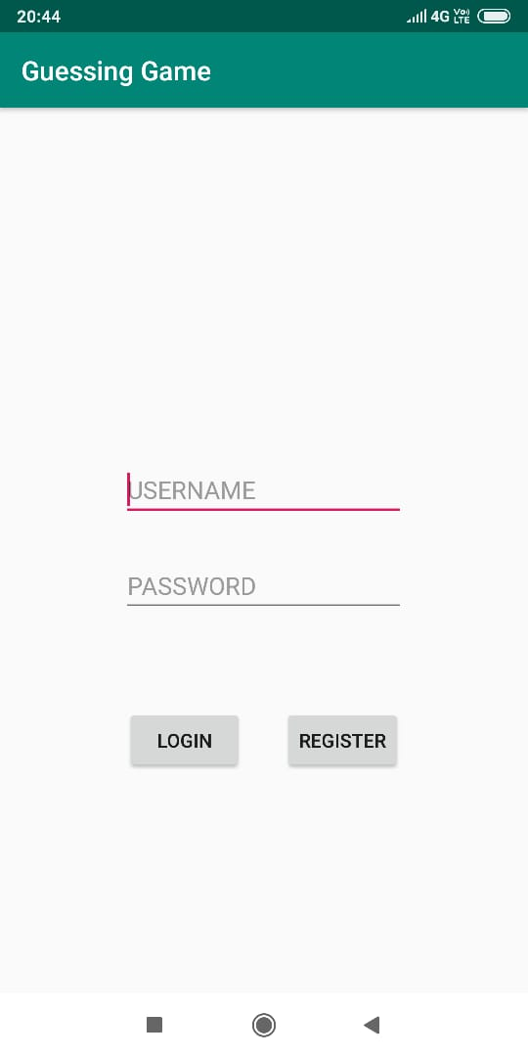 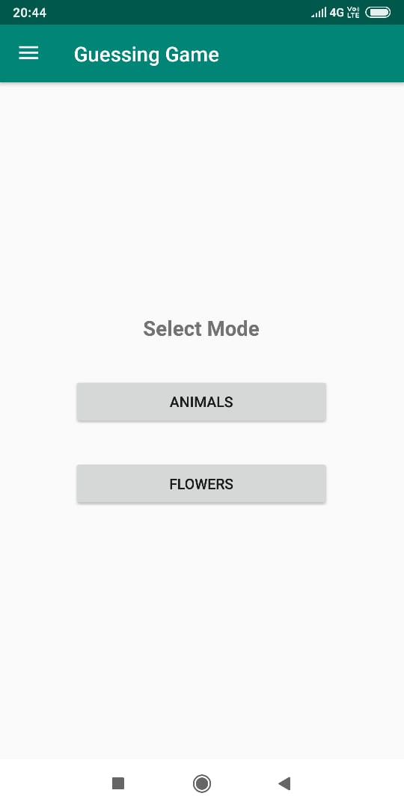

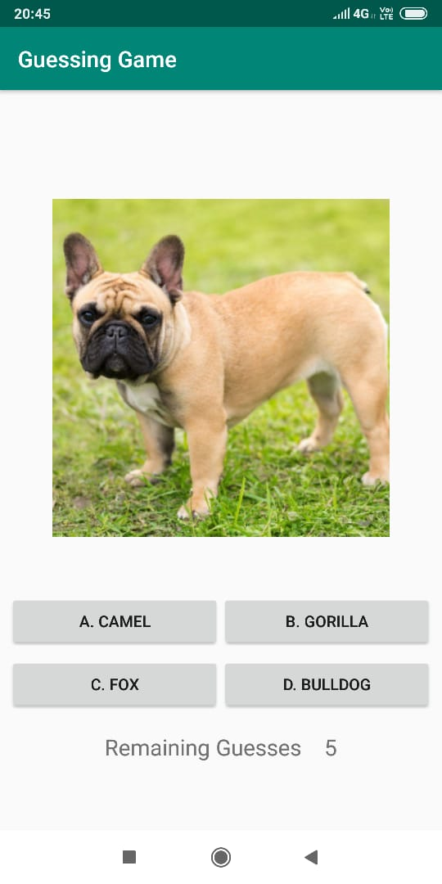 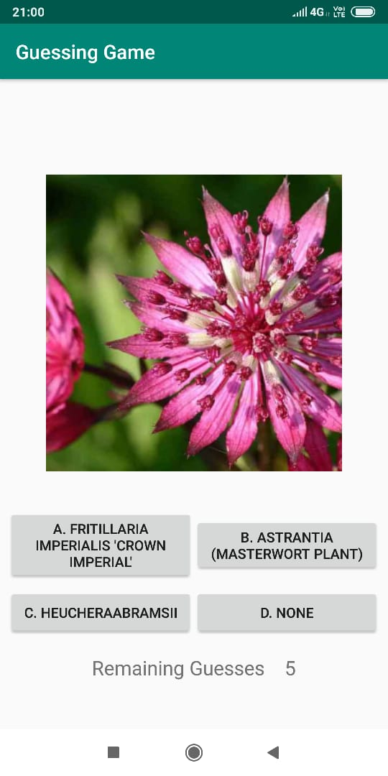

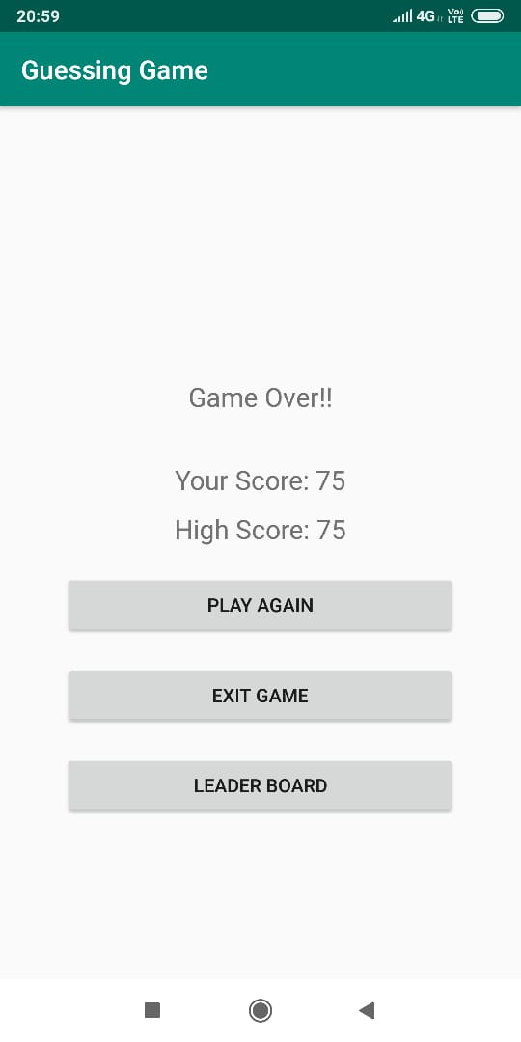 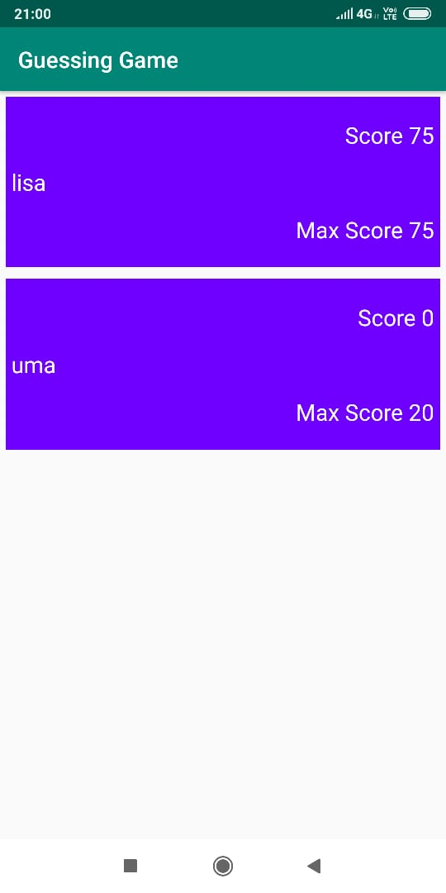

**FUTURE SCOPE**

As future projects, one can imagine many fields, not only directly concerning the Game Guess application. Of course, some minor adjustments have to be done to this app like if the player is giving the correct answer continuously then automatically the nest question is going to be tough then the previous one and if the player is giving an incorrect answer then the next question will be easy then the previous question. It should be ready to be deployed via the Android market. The UI could be polished a bit to match the design of modern mobile applications. Additionally, some system parts can be improved, mainly in the area of routing performance, to guarantee a smoother and faster experience for the user.

Nevertheless, one of the big strengths of this project is definitely the amount of easily, reusable Java packages. As the whole code is open-sourced, all parts can be used to build other related game applications.

**CONCLUSION**

Several goals were accomplished while working on this team project. First of all, an application was created which supports a user’s day planning with the following implemented functionalities:

* Generate a day plan, which is heavily optimized on completing as many tasks as possible.
* Simple, yet powerful task management system.
* Continuous checking of the dayplan’s consistency and compliance.

The task management functionality of this app is also strongly encapsulated and can therefore be reused easily in any Java project. The storage mechanism of converting tasks into events and storing them at a specific name can also be adapted easily to a Realm database or any other preferred storage solution.